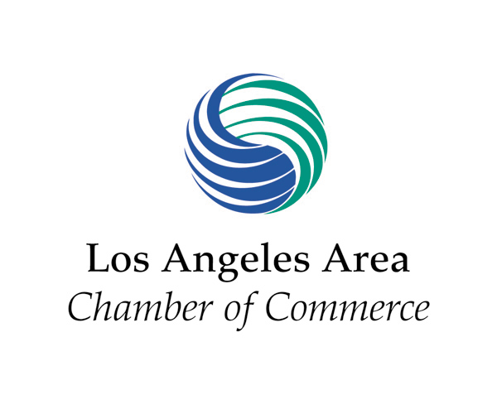
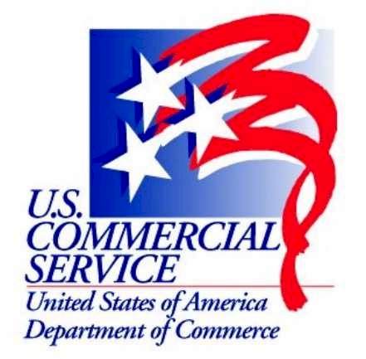

U.S. Commercial Service,
The California Energy Commission, and
The Los Angeles Area Chamber of Commerce

Invites You to Attend:
Asia Clean Energy Technology Opportunities Workshop
October 26, 2006 / Los Angeles
Date: October 26, 2006
Time: 9:00 AM-12:00 PM

Location: Los Angeles Area Chamber of Commerce, Board Room
350 Bixel St., Los Angeles, CA. 90017
For more information please contact Alex McElroy
Tel: (213) 894- 5435; Fax: (213) 894- 8788

Participation fee: $25 pre-registration; $35 at door

The California Energy Commission has a world-class Energy Export Program that routinely builds upon and supports the efforts of California firms in the development of clean and renewable energy in international markets. Join us for a fresh look at recent developments in renewable energy markets and an update on the California Energy Commission’s energy export financing program.

Program:

9:00 – 9:30 Registration
9:30 – 9:50 Update on market development in energy sector by Rachid Sayouty, Director, US DOC, Commercial Services-DTLA
9:50– 10:10 Financing Energy Projects: A Commercial Bank Perspective
Thomas Burr, Senior Vice President & Manager Export Finance, City National Bank
10:10 – 10:30 EXIM Bank: Private Sector Financing Capabilities
David Josephson, Regional Director EXIM Bank of the U.S.
10:30 – 11:30 California’s Energy Export Program: focus on project finance
Tim Olson, Manager, California Energy Commission
11:30 – 12:00 Q&A and discussion

Registrations are required by October 21.

Reservation rate: □ $25 for Clients of US Commercial Service
□ $35 registration at the door, space permitting

Name(s)_____________________________________________________________________________________

Company____________________________________________________________________________________
Address ___________________________________________________City/State/Zip ______________________

Phone ( )_________________ Fax ( )___________________ E-mail______________________________

Please charge $___________ to ___VISA ___MasterCard # ____________________________________________

Exp Date: ________________________Name (as it appears on credit card)_______________________________

Signature_______________________________ Zip associated w/ credit card if different than above: ___________
Please register by October 21, 2006. No Refunds after October 21, 2006. Space is limited. Please fax forms with credit card information to: (213) 894-8788; Send checks to US Department of Commerce, 444 S. Flower St., L.A. CA. 90071. For more information please contact Alex Mc Elroy at (213) 894-5435 or email: districtexportcouncil@earthlink.net.

