


The 4th China (Shenzhen) International Cultural Industries Fair

International Cultures Hall

Time: May 16th to 19th, 2008 (Friday to Monday)
Venue: Hall 7, Shenzhen Convention and Exhibition Center, China

Hosts:
Ministry of Culture of the People's Republic of China
Ministry of Commerce of the People's Republic of China
State Administration of Radio, Film and Television
General Administration of Press and Publication of the People's Republic of China
Guangdong Provincial People's Government
Shenzhen Municipal People's Government

Sponsors:
Shenzhen Press Group
Shenzhen Media Group
Shenzhen Publication and Distribution (Group) Company
Shenzhen International Cultural Industry Fair Co., Ltd.
Exhibition Schedule:
Exhibition period: May 16th -19th, 2008 (4 days)
8:30-17:30, May 16th and 19th, 2008
8:30-21:00, May 17th and 18th, 2008
Booth installation： May 13th-15th, 2008
Booth removal： 17:30-22:00，May 19th, 2008
8:30-17:00，May 20th, 2008

Foreword

Hosted by Ministry of Culture of the People's Republic of China, Ministry of Commerce of the People's Republic of China，State Administration of Radio, Film and Television, General Administration of Press and Publication of the People's Republic of China, Guangdong Provincial People's Government and Shenzhen Municipal People's Government, China (Shenzhen) International Cultural Industries Fair (ICIF) is the only nation-standard, international, comprehensive cultural fair of China. With exhibition and exchange as its cores, ICIF makes effort to establish a trade platform for Chinese cultural products and projects, develop China's cultural industries, promote Chinese cultural products to the world, and also enhance the exchange of Chinese culture with other cultures worldwide.

The first ICIF was held successfully in 2004, and an integrated platform was built for displaying cultural products, trading cultural industries factors and exchanging information in cultural industries. Based on this, the second ICIF had seen a further increased level in internationalization, market orientation and specialization and, especially, in facilitating trade. Emphasized on internationalization, market orientation, specialization, standardization and high quality, the 3rd ICIF established a brand of top exposition and export of Chinese cultural products.

The 4th ICIF will be held in May 2008. In order to promote the worldwide cultural exchange and cooperation, from the 4th session, ICIF will have an International Cultures Hall. The display scope will include: foreign cultural images, outstanding cultural and art products and projects, tourism resources, education achievements, performances, cultural heritage, images and products of brand cultural enterprises, etc.

We sincerely invite foreign government officials, organizations, entrepreneurs and professionals who are interested in the promotion and exchange of cultures worldwide, or in the cultural industries, especially manufacturers of cultural products and providers of cultural services, strategic and risk investors in the cultural industries, and the sellers, buyers and agents of cultural products, to send delegations of a country or organization or enterprise or as an individual to participate in the China (Shenzhen) International Cultural Industries Fair, so as to promote the exchange and development of cultures worldwide.

International Cultures Hall is set in Hall 7, Shenzhen Convention and Exhibition Center. Covering 7500 square meters, the hall will have 306 standard booths. It is divided into four sections.

Exhibition Area of International Cultures
Display scope: Display of foreign government and their cultural features, including the foreign country images, special cultural products and service, cultural images and features, cultural projects, policies and regulations in the cultural industry and on the import and export of cultural products, etc. This area is set for introducing outstanding foreign cultural projects, and looking for worldwide cooperation.
Target exhibitors: government-organized exhibition delegations, cultural enterprises, cultural associations and cultural industrial bases, etc.

Exhibition Area of International Tourism
Display scope: Display of foreign tourism resources, including the excellent travel routes, travel services, special tourism projects, tourism products, images of tourism organizations, etc. This area is set for displaying foreign tourism resources, and looking for worldwide cooperation.
Target exhibitors: foreign tourism organizations (both governmental and civil), and their agencies in China.

Exhibition Area of International Brand Cultural Achievements
Display scope: brand images, products and projects of the foreign outstanding culture and art brand, organizations of culture and art, international education and training organizations, international investment organizations, etc. This area is set for these organizations to develop worldwide business cooperation.
Target exhibitors: the brand cultural and art enterprises, the investment organizations, the education and training organizations, the education service organization, including their offices in China.

Negotiation and Activity Area for International Cultural Promotion
Activity scope: various cultural activities, such as competitions, lectures, promotion conferences, negotiations on cultural exchange and cooperation, etc.
Target participants: foreign cultural organizations and enterprises.
Review of the overseas exhibition area
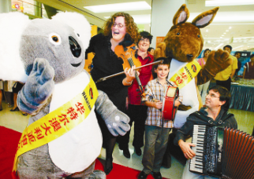
澳大利亚组团参展第三届文博会并成功合作举办澳大利亚文化周
The Australian exhibition delegation participated in the 3rd ICIF

韩国旅游发展局驻广州办事处组团参展第三届文博会
The Korea Tourism Organization participated in the 3rd ICIF

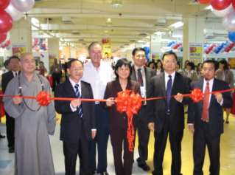
马来西亚光华日报社代理并组织马来西亚企业参展二届、三届文博会，并联合设立文博会马来西亚分会场
Malaysia Kwongwah Daily cooperated with us as an agency in 2nd and 3rd ICIF. And ICIF cooperated with Malaysia Kwongwah Daily to hold ICIF in Malaysia as a sub-venue.

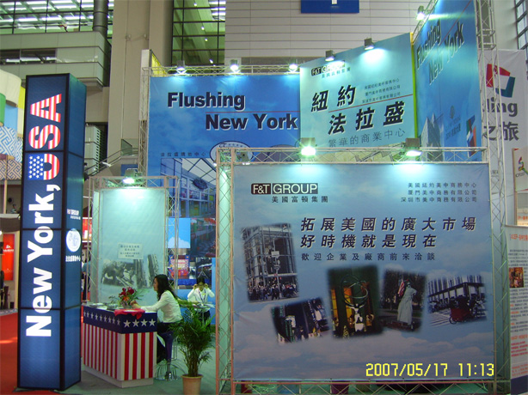
美中商务中心、美国富顿集团参展文博会
China US Net Group Inc. and FULTONEX Group participated in the 3rd ICIF

